3GPP TSG-RAN WG4 Meeting #119 R4-2606860

Dalian, China, May 18th – 22nd, 2026

Title: Discussion on feasibility and RF requirements study of sensing for 6GR
Source: Samsung
Agenda item: 8.10.3
Document for: Approval

Introduction
In RAN#108, the Integrated Sensing and Communication (ISAC) on 6G Radio (6GR) has been approved as a new study item ^{[1,2]}, where RAN4 working group is expected to study and discuss the physical functions and procedures, RF, coexistence, and testability for radio sensing.
- Sensing – Studies to be based on use cases and associated requirements, as defined in [TR38.914]
- PHY functions and procedures for sensing technology (e.g., waveform. reference signals, measurement feedback, etc…) [RAN1, RAN4]
- Evaluate sensing performance and if necessary, extend channel modelling, for the selected use cases [RAN1]
- Aspects of integration with communication services [RAN1]
- higher layer procedures and protocol aspects [RAN2]
- RAN4 aspects of sensing including RF, coexistence, and testability in coordination with other WGs [RAN4]
Note: RAN1 identify detailed requirements, if triggered by TSG RAN
In RAN#109, the key performance indicators and use cases of ISAC have been discussed, and the core technical performance requirements and basic use cases have correspondingly added to TR38.914 ^{[3]}.
In RAN4#118bis meeting, it is agreed that RAN4 start feasibility and coexistence study for 6G sensing for the TRP monostatic sensing mode with UAV detection/tracking, TRP-UE bistatic sensing mode with vehicle detection/tracking, TRP-TRP bistatic sensing mode, and TRP-TRP bistatic sensing mode with UAV detection/tracking at initial stage.
Issue 2-2: Use case and Issue 2-3: Sensing mode
Agreement for the feasibility study for 6G sensing:
- UAV (passive object), TRP monostatic
  - FFS on Multiple TRP monostatic.
- Vehicle (passive object), TRP-UE bistatic
- [TBD] (passive object), UE-TRP bistatic
- UAV (passive object), TRP-TRP bistatic
- In addition to above cases, other sensing modes/scenarios as agreed by RANP and RAN1 could be also studied.
In this contribution, the hardware feasibility for 6G sensing will be discussed.

Discussion

2.1 Feasibility study for TRP/UE–monostatic sensing

2.1.1 Antenna panel configuration scheme for sensing
For ISAC systems, the configuration of antenna pattern can influence the final performance of the ISAC system. In 6G sensing study, the common understanding is that the sensing task will reuse the communication hardware including antennas, which means that there would be no additional antenna array to be installed for sensing task. For monostatic sensing modes, transmit and receive antennas are collocated. Under such circumstances, the antenna panel would generally have two configurations to handle the signal transmission and reception need of sensing task, i.e.,
- Option 1: Separated antenna panel with simultaneous Tx signal transmission & Rx signal reception. In this configuration, define the total number of antennas to be L (also used in communication data transmission and reception), then the number of Tx antennas for monostatic sensing is L/2, and the number of Rx antennas for monostatic sensing is also L/2. While the Tx antennas transmits sensing signals, the Rx antennas also listening to the echo signal in the environment simultaneously.
- Option 2: Integrated antenna panel with Tx/Rx signal separated in different time slots. In this configuration, define the total number of antennas to be L (also used in communication data transmission and reception), then the number of Tx antennas for monostatic sensing is L, and the number of Rx antennas for monostatic sensing is also L. However, to allow the sensing receiver working normally rather than blocked by its own transmitted signal, the antenna panel has to work in a half-duplex model, which is that Tx signals and Rx signals occupy different time slot of antenna panel. An RF switch is utilized to toggle between the Tx and Rx functions of the antenna panel.
The antenna panel implementation illustration is shown in Fig. 1:

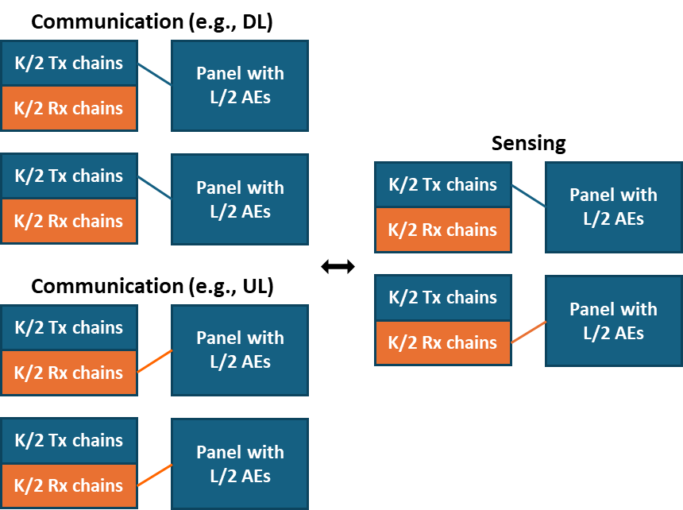 | 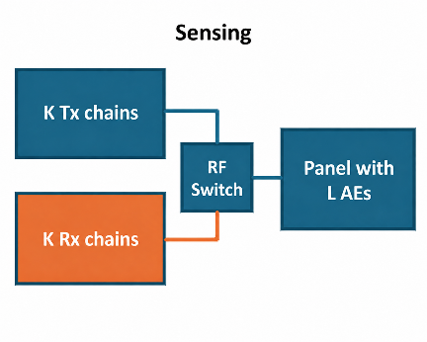
Option 1: Separated antenna panel with simultaneous Tx & Rx signals | Option 2: Integrated antenna panel with Tx/Rx signals separated in different time slots
Fig. 1 Antenna configuration for TRP monostatic sensing
In general, variations in antenna panel configurations create distinct RF propagation environments, thereby necessitating differentiated sensing signal processing algorithms. Option 1 allows sensing signals to be simultaneously transmitted and received. Thus, the self-interference from Tx antenna panel to Rx antenna panel would be inevitable. Option 2 avoid self-interference of sensing system by isolating signal transmission and reception in time domain. However, the Tx/Rx switching time would lead to blind zone for sensing system, which limited sensing application scenarios. In general, both antenna panel configurations are reasonable, and either configuration has its unique advantages and drawbacks. Thus, it is recommended that RAN4 to consider both antenna panel configuration in 6G sensing feasibility study.
- The common understanding is that the sensing task will reuse the communication hardware including antennas, which means that there would be no additional antenna array to be installed for sensing task.
- RAN4 to consider both separate and integrated antenna panel configuration in 6G sensing feasibility study.
In addition, since 6G BS will generally equip with larger antenna array and adopt sub-array antenna structure, there would be sufficient antenna elements for TRP and the separate antenna panel configuration scheme would not sacrifice much angle resolution loss. The separation antenna panel configuration would also bring benefits for short-range target sensing, which would fall into the blind zone if integrated antenna panel is used. Therefore, it is recommended that RAN4 to consider separate antenna panel (Option 1) as baseline configuration for TRP monostatic sensing in 6G study. However, for UE monostatic sensing, since the antenna elements for UE is much less than that of BS, there would be stringent trade-off between near-target sensing capabilities and angular resolution.
- RAN4 to consider separate antenna panel (Option 1) as baseline configuration for TRP monostatic sensing in 6G study.
- For UE monostatic sensing, since the antenna elements for UE is much less than that of BS, there would be stringent trade-off between near-target sensing capabilities and angular resolution.

2.1.2 Multiplexing schemes for sensing and communication
The selection of multiplexing method would decide the interference cancellation of an ISAC system and thus influence the architecture of an ISAC system. For multiplexing sensing and communication, four options can be considered in 6G study, i.e., time-division multiplexing (TDM), frequency-division multiplexing (FDM), spatial-division multiplexing (SDM), and code-division multiplexing (CDM).
For TDM scheme, sensing can be allocated with separate time domain resources with entire bandwidth, which is beneficial for achieving good range estimation performance. In this case, switching time may need to be considered when transitioning between sensing and communication. Note that for the monotonic sensing, simultaneous DL and UL (full-duplex) is needed.
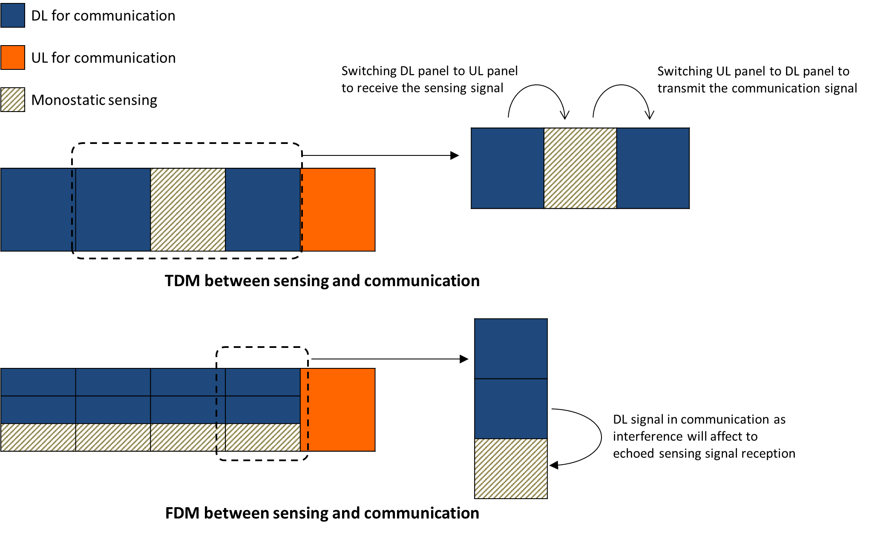
Fig. 2 Example of multiplexing methods for ISAC system

For FDM scheme, two primary scenarios of resource allocation between sensing and communication are typically considered: 1) where frequency resources for sensing are fully separated from those for communication, i.e., sensing and communication occupy mutually exclusive portions of frequency ranges in a band, and 2) where sensing RS mapping occupies a subset of subcarriers of a given frequency range and the remaining subcarriers are multiplexed for DL communication signals.
However, it is worth noting that for the FDM method, only a part of bandwidth is allocated to the sensing service. Thus, the sensing performance (e.g., sensing resolution) may be affected according to this frequency bandwidth configuration.
Apart from well-known TDM and FDM schemes, there are also SDM scheme and CDM scheme. For SDM scheme, the resources between sensing and communication are separated into different spatial region via different Tx beams. To utilize SDM scheme, the communication UE and sensing targets shall not locate in the same region / direction, and powerful beamforming capability of ISAC system is required. These prerequisites may limit the application scenarios of SDM scheme.
On the other hand, for the CDM scheme, the resources and signals of sensing and communications are separated by orthogonal code, but the detailed techniques still need further investigations.
Technically, in the context of target sensing task, frequency bandwidth and range resolution are a Fourier transform pair, where the attainable resolution is inversely proportional to the signal bandwidth. Thus, adopting FDM scheme will inevitably limit the available frequency bandwidth for sensing and lead to lower range resolution. Based on this analysis, it is recommended than RAN4 should priority TDM mode for communication and sensing task multiplexing within the 6G sensing feasibility and coexistence study.
- RAN4 to priority TDM mode for communication and sensing task multiplexing within the 6G sensing feasibility and coexistence study.

2.1.3 Self-interference between Tx and Rx antenna for sensing
In this subsection, we assume that the communication task and sensing task work in alternative time slots (i.e., TDM). Note that for integrated antenna panel configuration, the sensing signal transmission and reception also occupy different time intervals. The self-interference for this antenna configuration can also be neglected. Thus, the self-interference encountered in monostatic sensing would only be the interference signals from sensing Tx antennas to sensing Rx antennas for separate antenna configuration scenarios.
- The self-interference encountered in monostatic sensing would only be the interference signals from sensing Tx antennas to sensing Rx antennas for separate antenna configuration scenarios.
When sensing is implemented at the TRP using separate antenna configuration, the received echo signals at the TRP fall into the exact same frequency band as transmitted sensing signals, and thus are subject to co-channel co-band self-interference from the TRP side transmitter. Methods to cancel the self-interference include passive methods which rely on the antenna isolation between Tx and Rx antennas, active methods which utilize RF or digital signal processing, hybrid methods using a combination of these, and filtering.
- When TRP is using separate antenna configuration, the received echo signals at the TRP fall into the exact same frequency band as transmitted sensing signals, and thus are subject to co-channel co-band self-interference from the TRP transmitter.
Achieving a sufficient level of residual self-interference suppression and cancellation is the most critical part when implementing sensing at the TRP using separate antenna configuration. Without adequate SIC capability, the interference from the transmitted sensing signal would corrupt the received echo signal as illustrated in Figure 3 (a). To solve this problem, various SIC schemes can be used. Using the example of Figure 3 (b), SIC capability can be provided through the antenna or panel design (A), can be applied in RF domain to the RF signal (B) or in digital signal domain (C), or a combination of these.
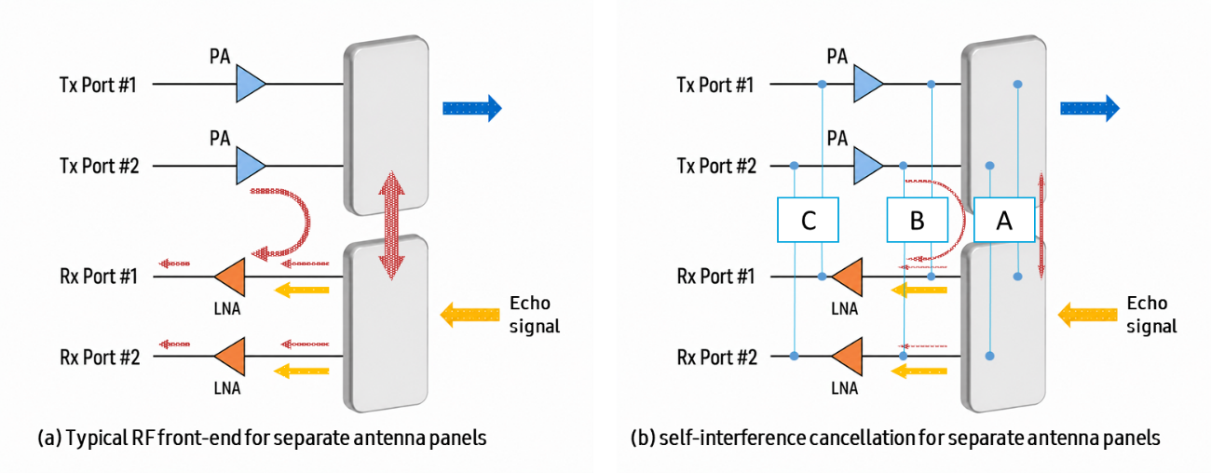
Fig. 3: TRP transceiver architecture with self-interference cancellation capability
For example, antenna SIC can be used to minimize the leakage power from the Tx ports to the Rx ports of the panel, and digital SIC is then used to handle any residual interference after antenna SIC. Tx sensing signal power flowing into the Rx path can be effectively suppressed below the noise floor level to guarantee the sensing receiver performance.
For the self-interference signal cancellation schemes, since the interference from sensing TRP transmitter to sensing TRP receiver is co-channel, co-band, the frequency isolation schemes are incapable of cancel sensing interference signal, only spatial isolation and digital cancellation schemes can be used.
- For self-interference cancellation in monostatic sensing, the frequency isolation schemes are incapable of cancel sensing interference signal, only spatial isolation and digital cancellation schemes can be used.
Note that there have been abundant self-interference cancellation analyses during Rel-18 SBFD study, it is recommended to use the isolation value in SBFD study as starting point in the self-interference cancellation study for 6G sensing.
- RAN4 to use isolation values in Rel-18 SBFD study as starting point for 6G sensing self-interference discussion.
Table 2.1.3-1: FR1 WA BS Self-interference Analysis
FR1 |  |  |  | Samsung | Samsung
TRP class |  |  |  | Wide Area BS  (subband filter-1) | Wide Area BS  (subband filter-2)
TRP TX Power $dB\left(P_{TX}\right)$ = ① dBm |  |  |  | 49 dBm | 49 dBm
Component  capability and parameters | Spatial isolation | Spatial isolation capability  $dB\left(α_{SI-spatial}\right)$ = ② dBc |  | 80 dBc | 80 dBc
 |  | Spatial isolation  techniques used |  | TX/RX panel separation and RF barrier structure | TX/RX panel separation and RF barrier structure
 | TX Beam nulling /isolation in TX band  $dB\left(α_{SI-beam}\right)$= ③ dBc |  |  | 10 dBc | 10 dBc
 | DL EIRP impact due to beam nulling in TX band |  |  | Limited, ~0dB | Limited, ~0dB
 | Self-interference leakage in TRP RX band  due to non-ideal TX, measured at RX ant. $dB\left(P_{SI_leakage}\right)$ (Note 1) |  |  | -41 dBm  Note: provided by  ①-②-④ dBm | -41 dBm  Note: provided by  ①-②-④ dBm
 | RF IC and other tech. (before LNA) | Impacts to RX sensitivity (due to e.g. insertion losses) due to RF IC or other techniques before LNA |  | Limited | Limited
 | Self-Interference signal in TRP TX band,  measured at the input of LNA $dB\left(P_{SI_TXSB}\right)$ (Note 1) |  |  | -41 dBm  Note: provided by  ①-②-③dBm | -41 dBm  Note: provided by  ①-②-③dBm
 | Blocker Suppression at RX | RX IMD | Rx IIP3 capability (dBm) | With subband filtering, RX non-linearity impact is neglectable | With subband filtering, RX non-linearity impact is neglectable
 |  |  | Rx IM3 contribution (dBm)
 |  | Other RX | Any other RX impacts if significant (e.g. ADC noise, phase noise etc.) | N/A | N/A
 | Self-Interference signal in TRP RX band caused by non-ideal RX selectivity, gain-normalized  $dB\left(P_{SI_Selectivity}\right)$(Note 1, 2) |  |  | -41 dBm  Note: provided by  ①-②-③dBm | -41 dBm  Note: provided by  ①-②-③dBm
 | RX Beam nulling /isolation in RX band  $dB\left(α_{SI-beam}\right)$= ④ dBc |  |  | 10 dBc | 10 dBc
 | RX sensitivity degradation caused by RX beam nulling |  |  | Limited, ~0dB | Limited, ~0dB
 | Digital IC $dB\left(α_{SI-digtial}\right)$ = ⑤ dBc |  |  | 20 dBc | 20 dBc
Overall RSIC capability $dB\left(RSIC\right)$ (Note 1)
Noise floor ⑥dBm |  |  |  | -96dBm/20MHz | -96dBm/20MHz
Residual Interference budget with 1 dB desens target (⑦dBm=⑥dBm-6dB) |  |  |  | -95 dBm | -95 dBm
Required RSIC budget (①-⑦dBc) |  |  |  | 144 dBc | 144 dBc
Sensing bandwidth configuration |  |  |  | 100MHz | 100MHz
Guardband assumption (if exist) |  |  |  | N/A | N/A
bandwidth over which suppression is achieved |  |  |  | 100MHz | 100MHz
Others
Table 2.1.3-2: FR2-1 WA BS Self-interference Analysis
FR2-1 |  |  |  | Samsung
TRP class |  |  |  | FR2-1 BS
TRP TX Power $dB\left(P_{TX}\right)$ = ① dBm |  |  |  | 30 dBm
Component  capability and parameters | Frequency isolation at TX | Frequency isolation capability $dB\left(α_{SI-frequency, TX}\right)$ = ② dBc |  | 0 dBc
 |  | Frequency isolation  techniques used |  | Without DPD
 | Spatial isolation | Spatial isolation capability  $dB\left(α_{SI-spatial}\right)$ = ③ dBc |  | 87 dBc
 |  | Spatial isolation  techniques used |  | TX/RX panel separation and RF barrier structure
 | TX Beam nulling /isolation in TX band  $dB\left(α_{SI-beam}\right)$= ④ dBc |  |  | 10 dB
 | DL EIRP impact due to beam nulling in TX band |  |  | Limited, ~0dB
 | Self-interference leakage in TRP RX band due to non-ideal TX, measured at RX ant. $dB\left(P_{SI_leakage}\right)$ (Note 1) |  |  | -67 dBm  Note: provided by  ①-②-③-⑨ dBm
 | RF IC and other tech. (before LNA) | RF IC capability and other tech. in TX sub-band $dB\left(α_{SI-RFIC}\right)$ = ⑤ dBc |  | 0 dBc
 |  | RF IC capability and other tech. in RX sub-band $dB\left(α_{SI-RFIC}\right)$ = ⑧ dBc |  | 0 dBc
 |  | RF IC techniques and other tech.  (before LNA) |  | Not applicable
 |  | Impacts to RX sensitivity (due to e.g. insertion losses) due to RF IC or other techniques before LNA |  | No impact
 | Self-Interference signal in TRP TX band, measured at the input of LNA $dB\left(P_{SI_TXSB}\right)$ (Note 1) |  |  | -67 dBm  Note: provided by  ①-③-④-⑤dBm
 | Blocker Suppression at RX | Frequency isolation capability  $dB\left(α_{SI-frequency, RX}\right)=$⑥ dBc |  | 0 dBc
 |  | Frequency isolation techniques |  | Filtering
 |  | RX IMD | Rx IIP3 capability (dBm) | IM3 contribution is  Neglectable
 |  |  | Rx IM3 contribution (dBm)
 |  | Other RX | Any other RX impacts if significant (e.g. ADC noise, phase noise etc.) | N/A
 | Self-Interference signal in TRP RX band caused by non-ideal RX selectivity, gain-normalized  $dB\left(P_{SI_Selectivity}\right)$(Note 1, 2) |  |  | -67 dBm  Note: provided by  ①-③-④-⑤-⑥dBm
 | RX Beam nulling /isolation in RX band  $dB\left(α_{SI-beam}\right)$= ⑨ dBc |  |  | 10 dBc
 | RX sensitivity degradation caused by RX beam nulling |  |  | Limited, ~0dB
 | Digital IC $dB\left(α_{SI-digtial}\right)$ = ⑦ dBc |  |  | 10 dBc
Overall RSIC capability $dB\left(RSIC\right)$ (Note 1)
Noise floor ⑩dBm |  |  |  | -83 dBm/100MHz
Residual Interference budget with 1 dB desens target (⑪dBm=⑩dBm-6dB) |  |  |  | -89 dBm
Required RSIC budget (①-⑪dBc) |  |  |  | 119 dBc
Sensing bandwidth configuration |  |  |  | 100MHz
Guardband assumption (if exist) |  |  |  | 5PRB
bandwidth over which suppression is achieved |  |  |  | 100MHz

It is also worth noting that the required RSIC budget in Table 2.1.3-1 and Table 2.1.3-2 are derived in Rel-18 SBFD study for communication purpose. In communication system, the interference signals must be suppressed within a certain level so that the received signal could be correctly demodulated and transmitted symbol could be perfectly recovered. However, for the sensing task, the requirement to the interference could be much less stringent. As long as LNA and other RF components are not blocked by the interference signal power, the interference signal can be regarded as a peak/clutter in the doppler-delay 2-D diagram, and be ignored at the digital processing stage by algorithms. Therefore, the required RSIC budget for the communication system is too stringent and not suitable for sensing task. It is recommended that RAN4 to design a new required RSIC budget dedicated for sensing task.
- The required RSIC budget for the communication system is too stringent and not suitable for sensing task.
- RAN4 to design a new required RSIC budget dedicated for sensing task.

2.1.4 Frequency accuracy requirement for speed/doppler estimation
In sensing, the speed of target is usually estimated based on the doppler shift of reflected echo signals. To gain accurate target speed, the frequency accuracy of sensing transmitter and receiver is required. During previous RAN plenary meeting, it is agreed that the sensing devices in 6G must meet the minimal requirements given in Table 2.1.4-1 ^{[3]}.
Table 2.1.4-1: Sensing-related requirements
 | Indoor Factory | Urban Macro
Detection Probability | 95% | 95%
False Alarm Probability | 5% | 5%
Horizontal Localization Accuracy | 2 m | 5 m
Vertical Localization Accuracy | N/A | 8 m (Note 1)
Velocity Accuracy | 2 m/s | 4 m/s
Note 1: The applicability of vertical localization accuracy depends on the type of sensing target.
For the urban macro scenario, the minimal velocity accuracy during sensing should be no larger than 4 m/s, which can be convert to a minimum doppler value of
(1)
under 7GHz sensing frequency assumption. The corresponding minimal observation window is calculated to be 5.36ms. According to the calculated doppler frequency based on the velocity estimation precision, the maximum frequency error within an at least 5.36ms observation windows should be 26.67ppb, which means the maximum frequency offset would be ±13.33ppb. Similarly, the minimal observation window for indoor scenario under 7GHz sensing frequency assumption would be 10.72ms and the corresponding maximum frequency offset is calculated as ±6.67ppb. Therefore, the sensing transmitter must guarantee its frequency (clock) accuracy during the time length of observation window.
For the low SNR scenarios, the sensing receiver may need accumulate multiple sensing received signal to improve processing gain. Under these circumstances, the observation window could be even larger, reaching tens of milliseconds. The feasibility of frequency accuracy for sensing transmitters could be questionable. Therefore, it is recommended that RAN4 to investigate the frequency accuracy requirement for speed/doppler estimation in 6G sensing feasibility study.
- For velocity sensing in urban macro scenario using 7GHz devices, the minimal observation window is calculated to be 5.36ms and the maximum frequency offset is at least ±13.33ppb within the observation window.
- For velocity sensing in indoor scenario using 7GHz devices, the minimal observation window is calculated to be 10.72ms and the maximum frequency offset is at least ±6.67ppb within the observation window.
- RAN4 to investigate the frequency accuracy requirement for speed/doppler estimation for monostatic sensing in feasibility study.

2.2 Feasibility study for TRP–UE/UE–TRP bistatic sensing

2.2.1 Feasibility of synchronization between different sensing transmitters and receivers
For the bistatic sensing scenarios, for example, TRP–UE or UE–TRP, the sensing transmitter and sensing receiver will deployment at different locations. Generally, for the sensing task like range detection, the distance of target is estimated by exploit the time difference between the sensing signal transmit and reception. For the monostatic sensing, sensing signal transmission and reception is controlled by a single device, and the clock accuracy for a single device can be assumed to good enough according to the sensing distance precision agreed in TR38.914, which is presented in Table 2.1.4-1. However, for the bistatic sensing, the sensing signal transmission and reception occurs in different devices. The sensing receiver must know the exact signal transmission time for the sake of accurate distance/location estimation. Currently, the horizontal location accuracy is set to be 5m for urban macro scenario ^{[5]}, and the corresponding time synchronization error for the bistatic sensing devices should less than 16.67ns. For the 2m location precision for indoor scenarios, the corresponding time synchronization error for the bistatic sensing devices has to be less than 6.67ns.
Concerning the required clock synchronization precisions for different devices are much larger than the TAE requirements for a single device. It is questionable that whether the clock synchronization requirement can be meet using current communication hardware architectures.
- RAN4 to investigate the minimal clock synchronization requirements for different bistatic sensing scenarios.

2.2.2 Frequency accuracy requirement for speed/doppler estimation
Similar to the monostatic sensing cases, for the speed/doppler estimation problem in bistatic sensing modes, the clock frequency accuracy is at least equally important. However, since sensing is conducted across different devices, the frequency accuracy requirement could be even harder to be guaranteed. Therefore, RAN4 should investigate frequency accuracy requirement for speed/doppler estimation for bistatic sensing in feasibility study.
- For the sensing tasks conducted across different devices, the frequency accuracy requirement could be even harder to be guaranteed.
- RAN4 should investigate frequency accuracy requirement for speed/doppler estimation for bistatic sensing in feasibility study.

Conclusion
In this contribution, we proposed following for the general aspects and regulatory requirement survey for 6G sensing:
- The common understanding is that the sensing task will reuse the communication hardware including antennas, which means that there would be no additional antenna array to be installed for sensing task.
- RAN4 to consider both separate and integrated antenna panel configuration in 6G sensing feasibility study.
- RAN4 to consider separate antenna panel (Option 1) as baseline configuration for TRP monostatic sensing in 6G study.
- For UE monostatic sensing, since the antenna elements for UE is much less than that of BS, there would be stringent trade-off between near-target sensing capabilities and angular resolution.
- RAN4 to priority TDM mode for communication and sensing task multiplexing within the 6G sensing feasibility and coexistence study.
- The self-interference encountered in monostatic sensing would only be the interference signals from sensing Tx antennas to sensing Rx antennas for separate antenna configuration scenarios.
- When TRP is using separate antenna configuration, the received echo signals at the TRP fall into the exact same frequency band as transmitted sensing signals, and thus are subject to co-channel co-band self-interference from the TRP transmitter.
- For self-interference cancellation in monostatic sensing, the frequency isolation schemes are incapable of cancel sensing interference signal, only spatial isolation and digital cancellation schemes can be used.
- RAN4 to use isolation values in Rel-18 SBFD study as starting point for 6G sensing self-interference discussion.
Table 2.1.3-1: FR1 WA BS Self-interference Analysis
FR1 |  |  |  | Samsung | Samsung
TRP class |  |  |  | Wide Area BS  (subband filter-1) | Wide Area BS  (subband filter-2)
TRP TX Power $dB\left(P_{TX}\right)$ = ① dBm |  |  |  | 49 dBm | 49 dBm
Component  capability and parameters | Spatial isolation | Spatial isolation capability  $dB\left(α_{SI-spatial}\right)$ = ② dBc |  | 80 dBc | 80 dBc
 |  | Spatial isolation  techniques used |  | TX/RX panel separation and RF barrier structure | TX/RX panel separation and RF barrier structure
 | TX Beam nulling /isolation in TX band  $dB\left(α_{SI-beam}\right)$= ③ dBc |  |  | 10 dBc | 10 dBc
 | DL EIRP impact due to beam nulling in TX band |  |  | Limited, ~0dB | Limited, ~0dB
 | Self-interference leakage in TRP RX band  due to non-ideal TX, measured at RX ant. $dB\left(P_{SI_leakage}\right)$ (Note 1) |  |  | -41 dBm  Note: provided by  ①-②-④ dBm | -41 dBm  Note: provided by  ①-②-④ dBm
 | RF IC and other tech. (before LNA) | Impacts to RX sensitivity (due to e.g. insertion losses) due to RF IC or other techniques before LNA |  | Limited | Limited
 | Self-Interference signal in TRP TX band,  measured at the input of LNA $dB\left(P_{SI_TXSB}\right)$ (Note 1) |  |  | -41 dBm  Note: provided by  ①-②-③dBm | -41 dBm  Note: provided by  ①-②-③dBm
 | Blocker Suppression at RX | RX IMD | Rx IIP3 capability (dBm) | With subband filtering, RX non-linearity impact is neglectable | With subband filtering, RX non-linearity impact is neglectable
 |  |  | Rx IM3 contribution (dBm)
 |  | Other RX | Any other RX impacts if significant (e.g. ADC noise, phase noise etc.) | N/A | N/A
 | Self-Interference signal in TRP RX band caused by non-ideal RX selectivity, gain-normalized  $dB\left(P_{SI_Selectivity}\right)$(Note 1, 2) |  |  | -41 dBm  Note: provided by  ①-②-③dBm | -41 dBm  Note: provided by  ①-②-③dBm
 | RX Beam nulling /isolation in RX band  $dB\left(α_{SI-beam}\right)$= ④ dBc |  |  | 10 dBc | 10 dBc
 | RX sensitivity degradation caused by RX beam nulling |  |  | Limited, ~0dB | Limited, ~0dB
 | Digital IC $dB\left(α_{SI-digtial}\right)$ = ⑤ dBc |  |  | 20 dBc | 20 dBc
Overall RSIC capability $dB\left(RSIC\right)$ (Note 1)
Noise floor ⑥dBm |  |  |  | -96dBm/20MHz | -96dBm/20MHz
Residual Interference budget with 1 dB desens target (⑦dBm=⑥dBm-6dB) |  |  |  | -95 dBm | -95 dBm
Required RSIC budget (①-⑦dBc) |  |  |  | 144 dBc | 144 dBc
Sensing bandwidth configuration |  |  |  | 100MHz | 100MHz
Guardband assumption (if exist) |  |  |  | N/A | N/A
bandwidth over which suppression is achieved |  |  |  | 100MHz | 100MHz
Others
Table 2.1.3-2: FR2-1 WA BS Self-interference Analysis
FR2-1 |  |  |  | Samsung
TRP class |  |  |  | FR2-1 BS
TRP TX Power $dB\left(P_{TX}\right)$ = ① dBm |  |  |  | 30 dBm
Component  capability and parameters | Frequency isolation at TX | Frequency isolation capability $dB\left(α_{SI-frequency, TX}\right)$ = ② dBc |  | 0 dBc
 |  | Frequency isolation  techniques used |  | Without DPD
 | Spatial isolation | Spatial isolation capability  $dB\left(α_{SI-spatial}\right)$ = ③ dBc |  | 87 dBc
 |  | Spatial isolation  techniques used |  | TX/RX panel separation and RF barrier structure
 | TX Beam nulling /isolation in TX band  $dB\left(α_{SI-beam}\right)$= ④ dBc |  |  | 10 dB
 | DL EIRP impact due to beam nulling in TX band |  |  | Limited, ~0dB
 | Self-interference leakage in TRP RX band due to non-ideal TX, measured at RX ant. $dB\left(P_{SI_leakage}\right)$ (Note 1) |  |  | -67 dBm  Note: provided by  ①-②-③-⑨ dBm
 | RF IC and other tech. (before LNA) | RF IC capability and other tech. in TX sub-band $dB\left(α_{SI-RFIC}\right)$ = ⑤ dBc |  | 0 dBc
 |  | RF IC capability and other tech. in RX sub-band $dB\left(α_{SI-RFIC}\right)$ = ⑧ dBc |  | 0 dBc
 |  | RF IC techniques and other tech.  (before LNA) |  | Not applicable
 |  | Impacts to RX sensitivity (due to e.g. insertion losses) due to RF IC or other techniques before LNA |  | No impact
 | Self-Interference signal in TRP TX band, measured at the input of LNA $dB\left(P_{SI_TXSB}\right)$ (Note 1) |  |  | -67 dBm  Note: provided by  ①-③-④-⑤dBm
 | Blocker Suppression at RX | Frequency isolation capability  $dB\left(α_{SI-frequency, RX}\right)=$⑥ dBc |  | 0 dBc
 |  | Frequency isolation techniques |  | Filtering
 |  | RX IMD | Rx IIP3 capability (dBm) | IM3 contribution is  Neglectable
 |  |  | Rx IM3 contribution (dBm)
 |  | Other RX | Any other RX impacts if significant (e.g. ADC noise, phase noise etc.) | N/A
 | Self-Interference signal in TRP RX band caused by non-ideal RX selectivity, gain-normalized  $dB\left(P_{SI_Selectivity}\right)$(Note 1, 2) |  |  | -67 dBm  Note: provided by  ①-③-④-⑤-⑥dBm
 | RX Beam nulling /isolation in RX band  $dB\left(α_{SI-beam}\right)$= ⑨ dBc |  |  | 10 dBc
 | RX sensitivity degradation caused by RX beam nulling |  |  | Limited, ~0dB
 | Digital IC $dB\left(α_{SI-digtial}\right)$ = ⑦ dBc |  |  | 10 dBc
Overall RSIC capability $dB\left(RSIC\right)$ (Note 1)
Noise floor ⑩dBm |  |  |  | -83 dBm/100MHz
Residual Interference budget with 1 dB desens target (⑪dBm=⑩dBm-6dB) |  |  |  | -89 dBm
Required RSIC budget (①-⑪dBc) |  |  |  | 119 dBc
Sensing bandwidth configuration |  |  |  | 100MHz
Guardband assumption (if exist) |  |  |  | 5PRB
bandwidth over which suppression is achieved |  |  |  | 100MHz
- The required RSIC budget for the communication system is too stringent and not suitable for sensing task.
- RAN4 to design a new required RSIC budget dedicated for sensing task.
- For velocity sensing in urban macro scenario using 7GHz devices, the minimal observation window is calculated to be 5.36ms and the maximum frequency offset is at least ±13.33ppb within the observation window.
- For velocity sensing in indoor scenario using 7GHz devices, the minimal observation window is calculated to be 10.72ms and the maximum frequency offset is at least ±6.67ppb within the observation window.
- RAN4 to investigate the frequency accuracy requirement for speed/doppler estimation for monostatic sensing in feasibility study.
- RAN4 to investigate the minimal clock synchronization requirements for different bistatic sensing scenarios.
- For the sensing tasks conducted across different devices, the frequency accuracy requirement could be even harder to be guaranteed.
- RAN4 should investigate frequency accuracy requirement for speed/doppler estimation for bistatic sensing in feasibility study.

References
- RP-251861 “New SID: Study on Integrated Sensing and Communication (ISAC) for NR,” RAN#108
- RP-251881, “New SID: Study on 6G Radio,” NTT DOCOMO (Moderator), 3GPP TSG RAN Meeting #108, Prague, Czech Republic, June 9-13, 2025.
- RP‑260073 “TR38.914 ‘Study on 6G Scenarios and Requirements (Release 20)’”
- RP-260819 “Moderator's summary for RAN led 6G SI: Requirements of new and existing services”, Moderator (CMCC), 3GPP TSG RAN Meeting #111, Fukuoka, Japan, March 9-12, 2026.
- RP‑260073 “TR38.914 ‘Study on 6G Scenarios and Requirements (Release 20)’”
- TR 38.858, “Study on Evolution of NR Duplex Operation”
- R1-2505582 “Design of 6GR air interface”, Samsung, 3GPP TSG RAN1 Meeting #122
- R1-2505583 “Evaluation assumptions for 6GR”, Samsung, 3GPP TSG RAN1 Meeting #122
- R1-2505580 “Discussion on ISAC Evaluation assumptions and performance evaluation”, Samsung, 3GPP TSG RAN1 Meeting #122
- R1-2507250 “Discussion on ISAC evaluation assumptions and performance evaluation”, Samsung, 3GPP TSG RAN1 Meeting #122b
- R1-2600750 “Evaluation assumptions for 6GR”, Samsung, 3GPP TSG RAN1 Meeting #124

